**COMP3760: Lab3**

**A01052311**

**Set O**

**Dongsun Kim**

**Step of main function:**

1. Read .txt file and convert all text words to Java string array.

2. Prints the number of words from .txt file.

3. Set the timer for execution time and find the number of anagrams for each words with first technique.

4. Print execution time of first tech.

5. Set the timer for execution time and find the number of anagrams for each words with second technique.

6. Print execution time of second tech.

7. Set the timer for execution time and find the number of anagrams for each words with third technique.

8. Print execution time of third tech.

**Results:**

**First Tech**

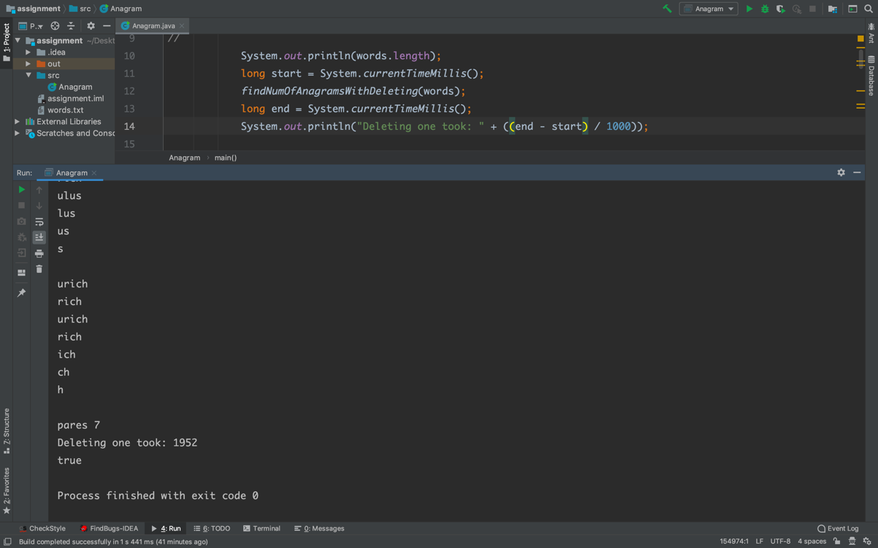

**Second Tech**

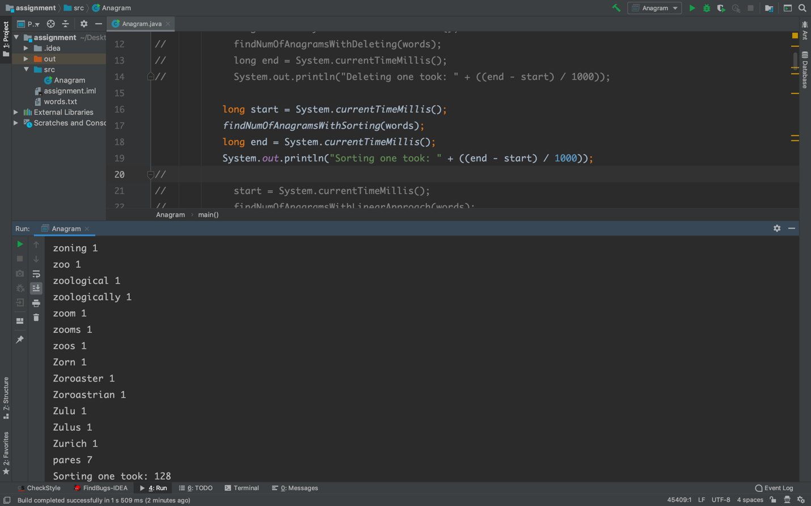

**Third Tech**

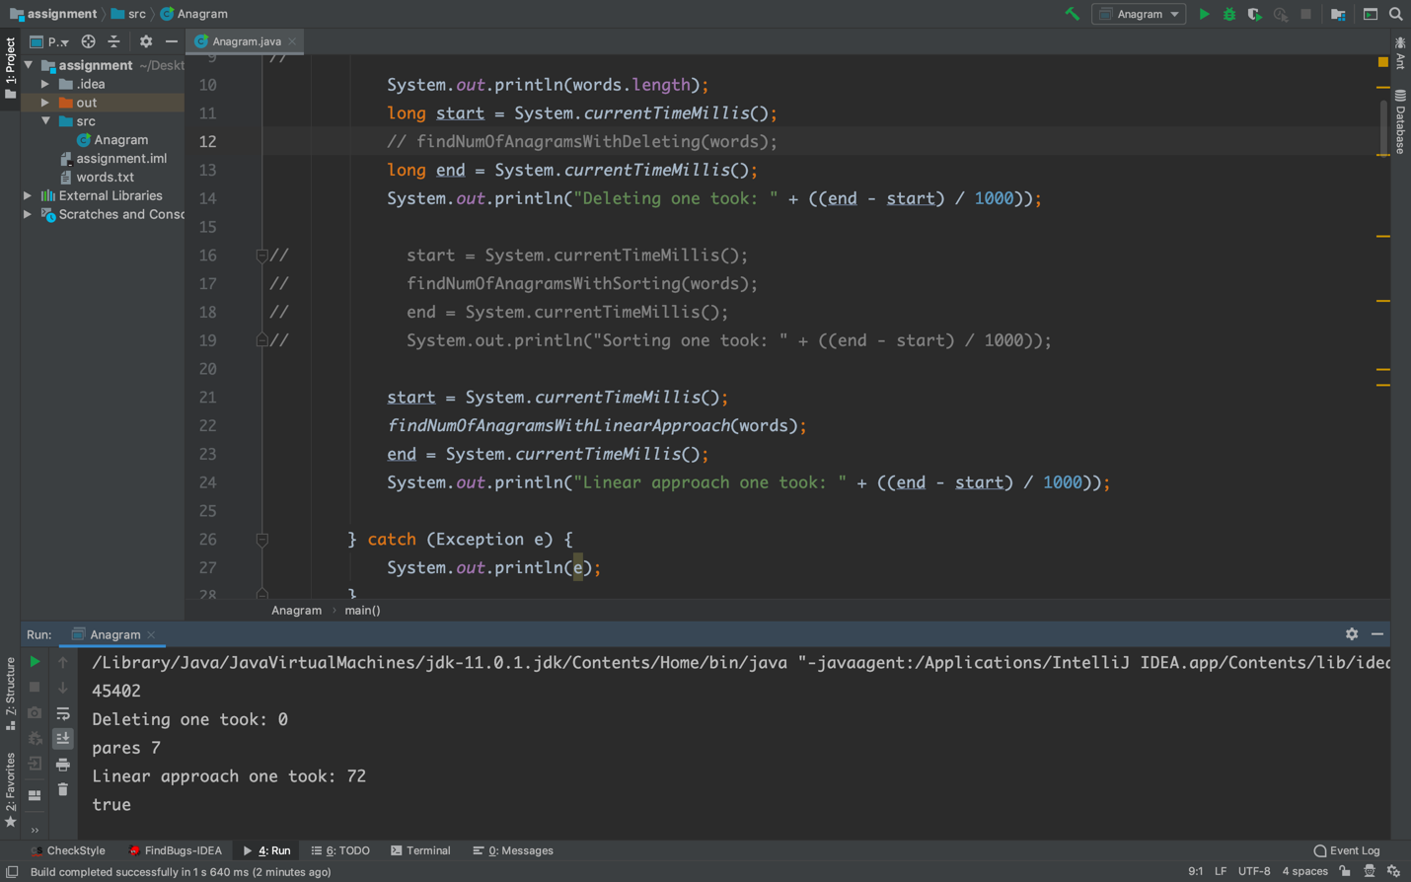

**Conclusion:**

**'pares' has 7 anagrams as the most number from dics.**

First technique takes O($n^{2}).$

Second technique takes O(nlogn).

Third technique takes O(n).

Therefore, the third technique is fastest for finding the word (or words) that have the largest number of anagrams.